Shanghai Wander: Vibe & Vision
Part 1. Abstract
This project proposes an "City Walk Route Guide" designed for young tourists with limited leisure time who focus on short trips, enjoy city landscapes and entertainment consumption. The project will initially focus on five famous "city-walk" streets in Shanghai: Yuyuan Road, Anfu Road, Wukang Road, People's Square and Huaihai Road. By organizing multiple visual data (photos, descriptions, and social media comments) on interactive Google Maps (Fig.1), it provides users more referenceability to explore cities and enjoy short vacations, avoiding the unpleasant experience of wasting limited time. As tool for developing multi-dimensional information and assisting urban exploration, this project will promote public awareness and reflection on "internet celebrity culture" and improving SDG 12[7], cater to the consumption and travel habits of young people, and provide an example of information visualization for other tourism industry.
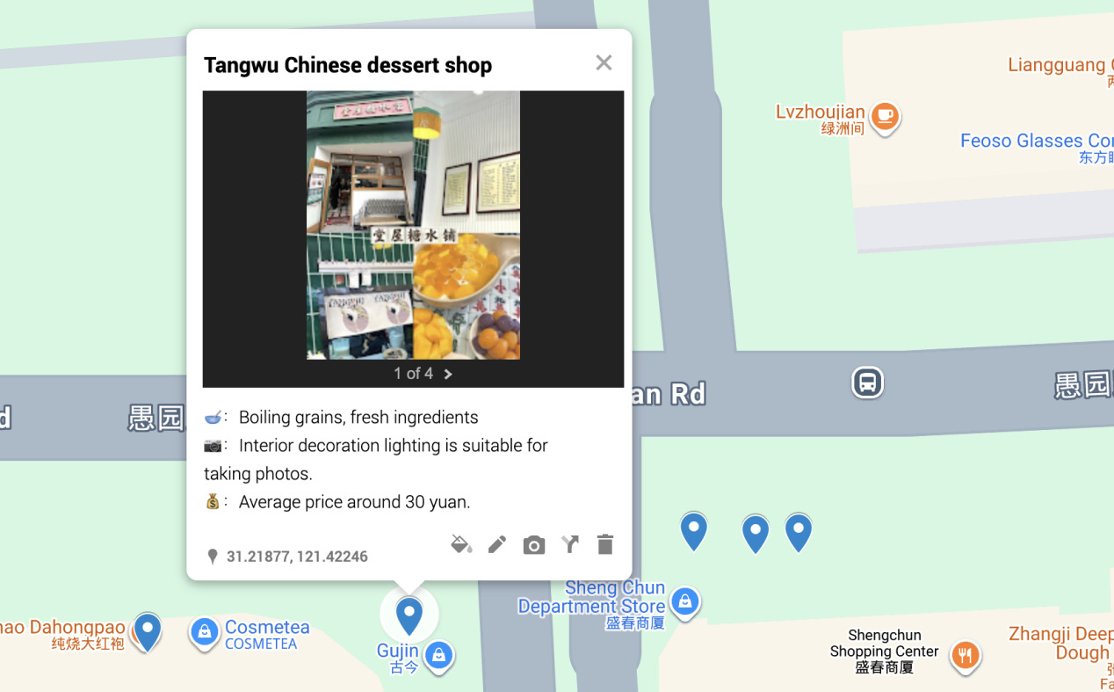
Fig. 1 Teaser Figure: Interactive Map Interface Showing City Walk Routes with Filters and User Reviews.

Academic Professionalism Block

Disclaimer
This project is submitted for INFOSCI 301 Data Visualization and Information Aesthetics, Spring 2026, instructed by Professor Luyao Zhang at Duke Kunshan University
2. Acknowledgments
We thank Professor Luyao Zhang for her guidance, our peers for valuable feedback, and our community partners—Jiading Urban Planning Exhibition Hall, Waving Cube Museum, and Kunshan Museum of Chinese Opera—for inspiring our design.
3. Contribution to SDG Goals
- SDG 11 (Sustainable Cities): Encourages balanced urban exploration and reduces over-tourism.
- SDG 12 (Responsible Consumption): Helps users make informed choices, supporting authentic local businesses.
4. Statement of Accessibility
All materials are publicly available:
GitHub: https://github.com/FionaChen623/City-Wander-with-Vibe-Vision
Hugging Face: https://huggingface.co/datasets/JocelynGUO/INFO_Shanghai_Map_Guide

Keywords

Information visualization; city walk; community-based learning; sustainable tourism; interactive map; Shanghai; cultural heritage; responsible consumption.

Part 2. Value — Community-Based Learning & Social Impact

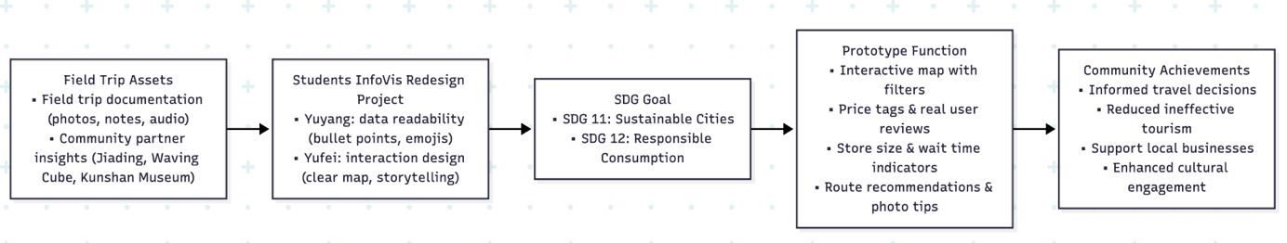Fig. 2. Community Impact Flow Chart
2.1 Targeted Community
Our visualization project mainly serves young tourists and residents in Shanghai who have limited leisure time and focus on budget. This group is the most active participant and subject in the city's "internet celebrity" consumer culture, relying on social media to explore travel destinations. However, they are now facing serious information asymmetry, often encountering disappointing experiences such as idealized online performance and high prices (such as 50 yuan per cup of coffee), overly commercialized spaces, and real-life scenes that are completely different from social media images. Our project enables this community to break through the dilemma of information asymmetry, develop urban landscape tours through multidimensional information, and make full use of limited rest time and financial resources.
2.2 Community based learning connections
Our project has a different emphasis on viewing content compared to field trips. The Jiading Urban Planning Exhibition Hall showcases the top-down, data-driven urban development process and future vision, which is an official narrative presentation of data. In contrast, our project uses data visualization to build a bottom-up, ordinary citizen based platform (as shown in Fig.2). This project utilizes visualization technology to help users penetrate the consumer fantasy woven by algorithms and capital, and touch on a more grounded experiential reality. Therefore, our map integrates these insights and uses data visualization technology to critically reveal the "deceptive" internet celebrity tourism economy, while also providing comprehensive information for young tourists with corresponding needs, so that they can weigh the pros and cons and make better tourism route planning with abundant information.
2.3 Applied Learning & Critical Reflection
The platform serves as an applied learning tool that explicitly designed around the critical reflection cycle—experience, analysis, abstraction, and application—which is fundamental to deepening learning in community-based contexts [4]. And it will transform them into practical resources for community self-protection and sustainable consumption.
Firstly, our project will implement the key findings of Jakarta spatial research. This study suggests that the aesthetic of "installable programs" is not an organic cultural trend, but a thoughtful business strategy aimed at redesigning spaces to maximize foot traffic and revenue [1]. There is a direct negative inference in the consumption pattern of Shanghai: it promotes both homogenization (streets crowded with visual similarity and theme driven bakeries and cafes) and deceptive marketing (a large number of edited photos masking mediocre reality). Our map addresses this issue by crowdsourcing and visualizing the gap between business planning images and life experiences, enabling users seeing through strategies and make informed choices.
Secondly, our methodology is inspired by the practicality of architectural level spatial analysis in Hong Kong [3]. Like Hong Kong, Shanghai is a high-density mega city with extremely scarce and expensive land resources. This economic pressure exacerbates the problems as businesses face high rents that are often passed on to consumers at inflated prices. In this situation we must promote the effective utilization of existing urban structures. Therefore, by highlighting regions and companies that provide true value, authenticity, and fair pricing, we guide users to make reasonable choices.
By linking the diagnosis of the problem with the method of finding solutions, our project transforms users from passive urban spatial consumption to active and analytical understanding of their economic and social forces, ultimately forming more powerful and sustainable consumption behaviors.
2.4 SDG Alignment
This project focuses on the unhealthy "internet-celebrity economy" and related consumption, which will help reduce unnecessary transportation related carbon dioxide emissions and resource waste (such as food waste and time waste), and contribute to SDG 11 sustainable cities and SDG 12 responsible consumption.[7]

Part3. Data Sources & Data Governance
3.1 Data source
To ensure the depth, reliability, and public accountability of the project, our data work integrates authoritative open data with carefully curated community-generated content and divided into 3 clear stages:
- Official Open Data (Shanghai Municipal Administration of Culture and Tourism): We will use the official open dataset released by the Shanghai Culture and Tourism Bureau which provides verified information on public facilities, and cultural sites along targeted routes. It serves as a reliable baseline for mapping and helps us avoid factual errors in venue location and basic classification.
- Core data (manually collected by designers): This is the cornerstone of the initial version of the project. We implement a systematic data collection process for stores along the target routes: Firstly, information filtering(collected from social media, excluded official marketing content from merchants), content analysis (store attributes, space assessment and consumption level), and future expansion (user crowdsourcing).
Data governance
We promise to build this community resource with a transparent and responsible attitude. All data points will be clearly labeled with their source and date. And for data collected from social media, we’ll provide privacy protection. And details are listed in Table 1 and Fig 3.
Table 1. Data metadata table
Dataset Name | Source | Description | Variables | Temporal Coverage | License | Privacy Handling
Shanghai Cultural Open Data | Shanghai Municipal Administration of Culture and Tourism | Verified public facilities and cultural sites | Name, address, type, coordinates | 2023–2024 | Open data | No privacy issues
Social Media Comments | Xiaohongshu, Dianping | User reviews and photos | Rating, comment text, tags, image URLs | 2024–2025 | Educational use only | Anonymized, no user IDs
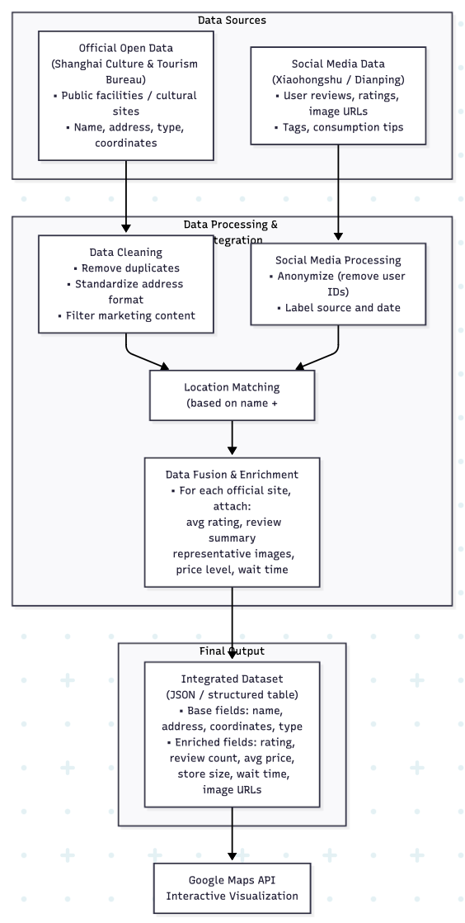
Fig. 3 Integrating official data with user-generated content

Part 4. Visualization Tools & Design Flow
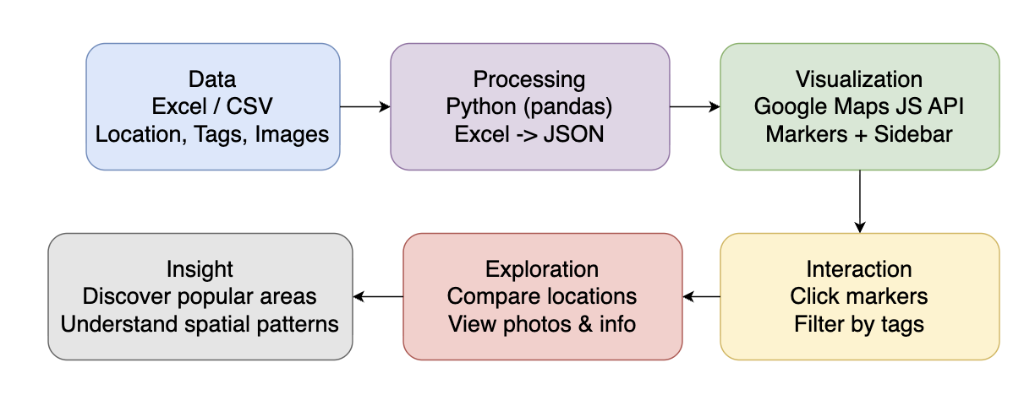
Figure 4. Visualization interaction flow for the Shanghai city-walk map project.
The diagram shows the pipeline from Excel data through Python preprocessing to JSON and Google Maps rendering, including user interaction and exploration steps.
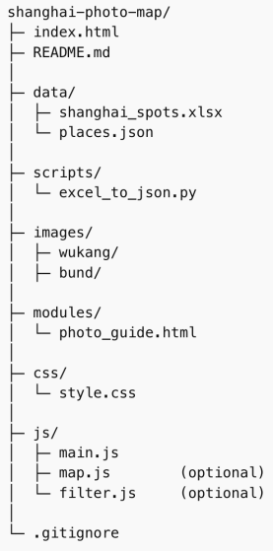
Figure 5. Project framework and Excel data schema.
Left: web application structure (HTML, CSS, JS, Python scripts, images, modules). Right: Excel schema defining columns feeding JSON for interactive visualization.

The client-side website is built with fundamental web technologies: HTML for page structure, CSS for visual styling, and JavaScript for interactive logic. We leverage the Google Maps JavaScript API to generate geographic markers for all featured spots; clicking a marker opens an InfoWindow displaying the location’s images, detailed descriptions, thematic tags, user reviews and other key information (see Fig 4, Fig 5). For an enhanced user experience, modular auxiliary features including photography guidance, a feedback form and nearby public transport recommendations are placed in a dedicated sidebar or as independent HTML modules. Users can filter markers by tags or categories, check in-depth location details and intuitively explore the spatial distribution of Shanghai’s popular city walk spots. The project follows a streamlined data pipeline where central updates to the Excel dataset are automatically synced to the web interface. We prioritize Excel data accuracy, rigorous Python preprocessing and Google Maps API performance optimization. The integrated design of data preprocessing and modular front-end ensures the project is scalable, maintainable and accessible to young local residents and tourists, effectively showcasing Shanghai’s urban culture, green spaces and community resources.
Part 5. Research Inspiration & Innovation
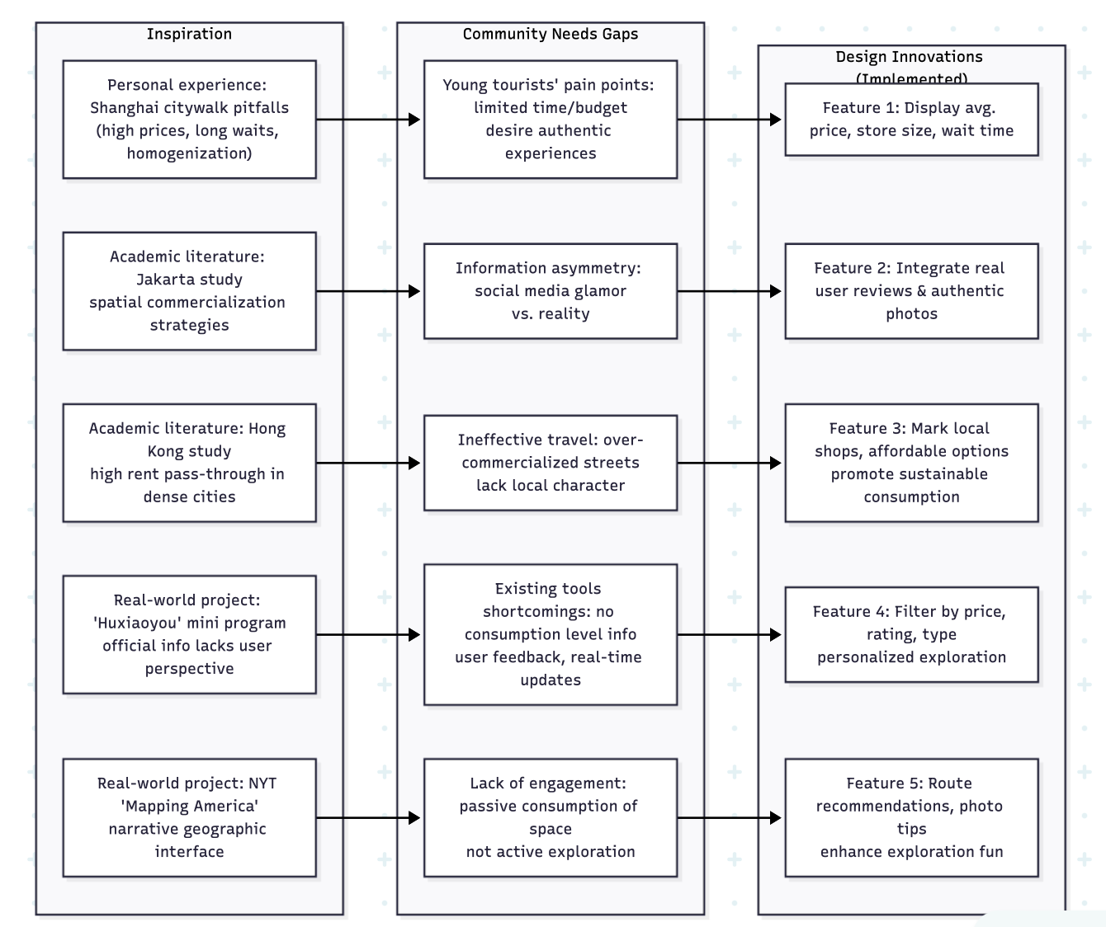
Fig. 6 Research Inspiration Flowchart
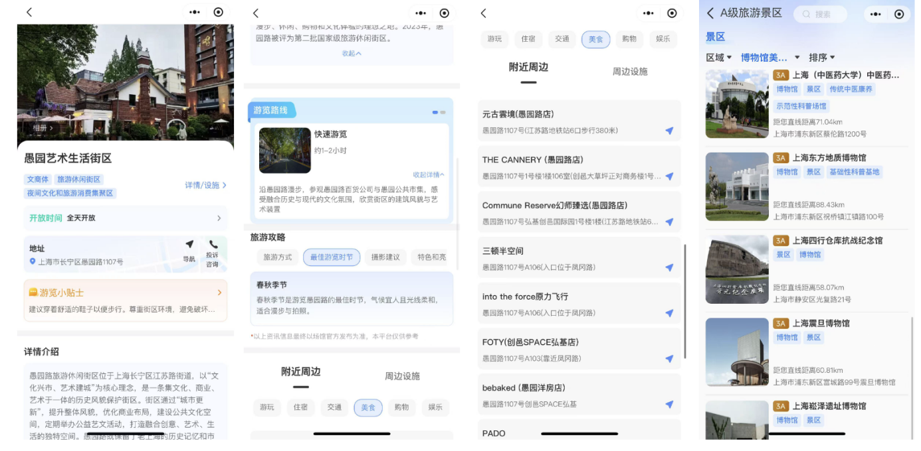
Fig. 7. Interface of the “沪小游” WeChat mini program.
The visualization provides official introductions to city walk streets in Shanghai, along with nearby restaurant names, map links, and indexes of museums and art galleries. It presents a lightweight, map-based reference for urban tourism exploration.
Our design draws inspiration from ReVISit 2’s visualization framework [5] and representative civic digital projects. ReVISit 2 supports full-cycle user studies through fine-grained interaction tracking and structured data management, while projects like The New York Times’ “Mapping America” show how narrative-driven geographic interfaces can effectively boost public engagement.
We also draw insights from existing tourism visualizations in practice. The “沪小游” WeChat mini program (Fig. 7) offers an official map-based overview of Shanghai’s city walk routes, demonstrating how lightweight mobile visualizations can support urban tourism. However, its content is largely limited to official street descriptions and a small curated set of mapped locations, with little user-generated feedback, consumption-level information, or timely updates.
From an academic perspective, Wu et al. [6] illustrate how social media data combined with visualization can uncover urban behavioral patterns at a city-wide scale. While useful for macro-level analysis, such approaches are less well-suited to supporting street-level, experience-focused decisions for young travelers with limited time and budget.
Our project builds on these works by adapting social-media-informed visualization to a micro-scale city-walk context. By integrating user comments, price ranges, store characteristics, and route-based exploration into an interactive map, we address the information gaps observed in both research systems and existing tourism platforms (Fig. 6), enabling more practical and reflective urban exploration for young residents and visitors.

Part 6. Team Makeup & Strengths
A. Team Makeup & Strengths
Our team consists of two members with complementary skills in data analysis, visualization design, and cultural research. Yuyang, a Data Science student with strong social science training, focuses on community-oriented research, urban cultural analysis, and narrative framing. Yufei, a Computer Science student, contributes technical expertise in Python-based data processing, visualization construction, and basic web development (HTML, CSS, JSON). Both members’ prior InfoVis Redesign Projects strengthened their ability to translate complex data and urban issues into accessible visual forms, enabling effective collaboration across research, design, and implementation.
B. Individual Reflection
Yufei Chen:
Working on the Jiading Urban Planning Exhibition Hall redesign shaped my perspective on translating complex urban data into actionable visualizations for diverse audiences. The project emphasized combining technical implementation with cultural and community awareness, showing me how interaction design and data preparation can influence user understanding and engagement. Insights from the Urban Futures field trip highlighted the importance of connectivity and accessibility in city layouts, inspiring me to prioritize clear map interactions and route guidance in our city walk visualization. The Living Cultural Heritage trip reinforced the value of integrating local context and storytelling, motivating me to include descriptive annotations and photos that convey neighborhood character. These experiences guided my role in implementing charts, interaction flows, and Python-based visualization tools, ensuring technical accuracy and user-centered design.
Yuyang Guo:
My INFO VIS redesign project focuses on the Kunshan bus online platform making me realize the importance of data readability: excessive text descriptions and pure image introductions are not advisable. Therefore, we presented the store introduction in bullet point format and used intuitive emojis as key prompts. Additionally, for most users, different landmarks on the map can be used as reference frames to determine the direction of the destination. Therefore, when inputting point and surface addresses, we strictly follow the relative positions between actual storefronts for data input to ensure that no erroneous information is generated. Moreover, the learning experience of the group discussion at the Kunqu Opera Museum made me more aware of the importance of balancing commercial and meaningful values, which also provided us with research directions to promote SDG12.
C. Team Contribution Statement
- Data Assets Contribution：Field trip documentation and social media data sourcing, including photos, notes, and external references, were collected by Yuyang. Dataset preparation and cleaning to ensure data readiness for visualization was handled by Yufei.
- Literature & Research Contribution：Review of academic literature, museum materials, and cultural context sources, as well as SDG alignment and ethical framing, was primarily conducted by Yuyang. Support for additional literature reading and conceptual discussion was provided by Yufei.
- Visualization Tools & Technical Contribution: Design of the interactive map and spatial visualization concept was done by Yuyang. Charts, interaction flows, and analytical/visualization tools using Python were developed by Yufei. Integration of visuals into the poster and prototype was a collaborative effort by both team members.

REFERENCES
[1] R. D. Aprilian and I. Widiastuti, “The story of adaptive reuse in Jakarta’s old building under the ‘instagrammable’ era,” in *Proc. 8th Biannual Int. Conf. ARTEPOLIS (ARTEPOLIS 2020)*, Bandung, Indonesia (Online), 2021. [Online]. Available: https://doi.org/10.2991/assehr.k.211126.019
[2] T. L. Trolian and E. A. Jach, “Applied learning in higher education: Conclusions and recommendations for institutional leadership,” *New Directions for Higher Education*, vol. 2019, no. 188, pp. 101–106, 2019.
[3] A. Maheshwari, Y. Jain, and S. S. Chopra, “Spatial inequity index for essential facility access at building-level in highly dense urban areas,” *Cities*, vol. 149, p. 104926, Jul. 2024. [Online]. Available: https://doi.org/10.1016/j.cities.2024.104926
[4] S. L. Ash and P. H. Clayton, “Generating, deepening, and documenting learning: The power of critical reflection in applied learning,” *Journal of Applied Learning in Higher Education*, vol. 1, pp. 25–48, Fall 2009.
[5] Zach Cutler, Jack Wilburn, Hilson Shrestha, Yiren Ding, Brian Bollen, Khandaker Abrar Nadib, Tingying He, Andrew McNutt, Lane Harrison, and Alexander Lex, “ReVISit 2: A Full Experiment Life Cycle User Study Framework,” in Proceedings of IEEE VIS 2025, Best Full Papers, Vienna, Austria, Nov. 2025. Available: https://ieeevis.org/year/2025/program/paper_ebdd5b65-b5cb-4d4b-bd78-92ff8cc2f243.html
[6] H. Wu, S. Zhao, X. Chen, and Y. Wu, “Visual Analysis of Urban Mobility and Social Media Data,” in Proc. IEEE VIS Workshop on Visual Analytics in Science and Technology (VAST), 2019. Available: https://pmc.ncbi.nlm.nih.gov/articles/PMC6359619/
[7] United Nations, “The Sustainable Development Goals Report 2023,” United Nations, New York, 2023. [Online]. Available: https://unstats.un.org/sdgs/report/2023/

Project Collaboration Links
-Collaborative Canva Poster URL
https://www.canva.cn/design/DAHAKIaG7JE/WDLXYKaW4u6ePYHpPes9fA/edit?utm_content=DAHAKIaG7JE&utm_campaign=designshare&utm_medium=link2&utm_source=sharebutton
-Collaborative GitHub Organization or Repository URL
https://github.com/FionaChen623/City-Wander-with-Vibe-Vision
-Collaborative Hugging Face Dataset URL
https://huggingface.co/datasets/JocelynGUO/INFO_Shanghai_Map_Guide/discussions?status=open&sort=recently-created
-Collaborative Demo URL
https://shanghaimap.my.canva.site
-Collaborative Teaser Video URL
https://www.capcut.cn/share/7607486843206260030?t=1

